1. *Create a *tidy* spreadsheet/table listing the names of Danish monarchs with their birth- and death-date and start and end of their reign. They should be sortable by year of birth. Suitable source website is for example*[*here*](https://kongehuset.dk/monarkiet-i-danmark/kongerakken)*, but you can also use another source, provided you reference it.*

I have attached my spreadsheet in the submission.

I used <https://www.kongehuset.dk/monarkiet-i-danmark/kongerakken> and <https://danmarkshistorien.dk/vis/materiale/kongeraekken> as my source.

1. *Does OpenRefine alter the raw data during sorting and filtering?*

No, it does not. OpenRefine changes the way we visualize the data, but it does not alter the raw data in any way.

Even if we for example create a new facet and use the Value.replace command, then we are only highlighting and changing the visual look of the data, but the raw data reminds the same.

1. *Fix the*[*interviews dataset*](https://ndownloader.figshare.com/files/11502815)*in OpenRefine enough to answer this question: "Which two months are reported as the most water-deprived/driest by the interviewed farmer households?"*
2. **First, I made a Facet that would show every month, however as you can see on the picture it is out of order because of all the symbols.**

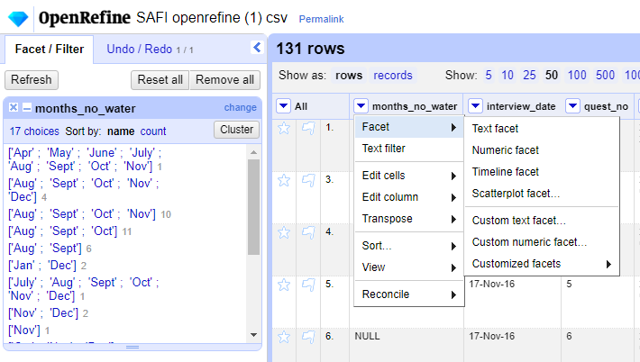

1. **Then I went into Edit cells -> Transform**

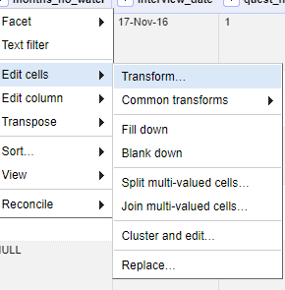

1. **In this menu I entered the expression:**

value.replace("[","").replace("]","").replace("'","").replace(" ","")

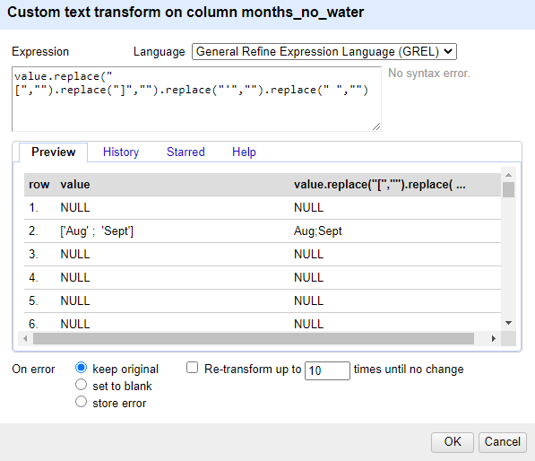

1. **This removes every special character and makes my new facet look like this:**

* However, it is still not tidy.

1. **To change this I went into Facet -> Custom text facet.**

* Then I entered the command value.split(“;”)

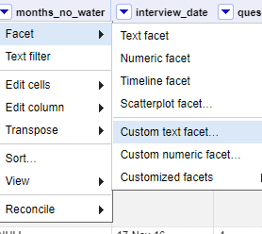

* This removes the ; from the facet and finally makes the months sortable.

1. **Lastly, I can now see which month is the driest by sorting by count.**

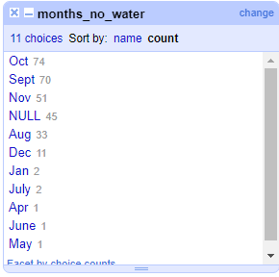

* October and September are the two driest months.